I am building a professional Lab Operations Dashboard in Power BI. I need you to act as a Power BI Expert and guide me through building this from scratch.
Context: The project tracks the flow of DNA test samples. The stages are: Date of Collection → Added Date → Processing → Validation → Validated.
The Core Rules (Crucial):
- No Relationships: I am NOT allowed to create relationship lines between tables in the Model view. All filtering must be handled through DAX 'programming' using the ALLSELECTED() function.
- Gender-Specific Logic: I am a boy, so I must follow the 'Boy' requirements:
  - For Age: Use ROUNDUP. o For Age Groups: Use the SWITCH function and label patients > 100 as 'Other'. o For TAT: Use ROUNDUP. o For Sorting: Age Group Donut chart must be sorted Ascending.
  - For Gauge Colors: If Average TAT > Target, show Red; otherwise, show Blue.
Required Visuals on a Single Overview Page:
- Last Refreshed Table: A table showing the last refresh date/time in EST, formatted with a '' between date and time (e.g., dd/mm/yyyy \ hh:mm).
- Funnel Chart: Showing the sequence: Added → Collection → Processed → Validated.
- Clustered Bar Chart (Specimen): Showing the count of patients in each of the 4 states (Added, Collected, Processed, Validated) for every specimen type.
- Billing Status Visual: A Bar chart filtered for the status 'Pending Billing Approval', showing counts for each of the 4 states.
- Scroller Visual: An imported custom visual showing the 'Pending Billing Approval' counts per Specimen.
- TAT Gauge: Showing the average turnaround time with a target of 7.
What I need from you: Please provide the step-by-step DAX formulas for the measures, especially how to create 'Manual Relationships' using VAR and SELECTEDVALUE since I cannot use the Model view. Start with the data cleanup for birthdates and the TAT calculation."

the statements from the professor( make the average TAT guage visual, and donut visual for age group

*Task 1:*
Field required from the given file = patientDOB
Calculate age and round in up.
Create new column named ‘Age group’ and insert a DAX formula to calculate it upto 100. Patients whose age is above 100, label them as ‘above 100’ (girls) or ‘other’ (boys)
DAX function to use for Age groups:
Nested if for girls
Switch for boys

The age groups will look like this…
1-5, 6-15, 16-25, …………………, above 100

Then make donut visual.
For girls: sort it descending
For Boys: sort it ascending
CR/GR: sum/avg wise

*Task 2:*
Fields required: statusValidateToValidated and AddedDate
Subtract both columns date and calculate their difference and named that column as ‘TAT’
Perform measures like sum, count, average, round on TAT column
RoundDown: for girls
RoundUp: for boys
Round: for CR/GR

Then make the Gauge visual.
Set the min,max and target value. And add the measure average that you calculated before. If your average TAT exceed the target value then color it red otherwise blue

like that
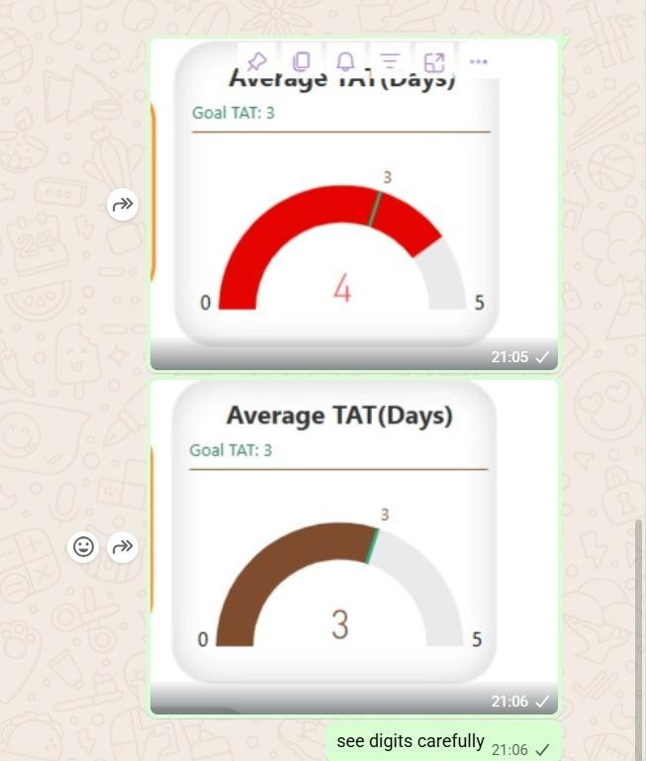
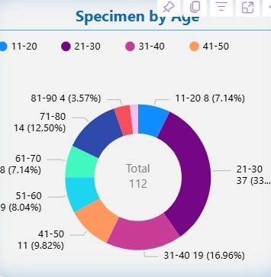

moving on to next

Making a last refreshed table:

- using direct query:
In power query, go to direct query, then editor then write there a piece of code (ask from internet or chatgpt how to display in EST) convert to table to view in dashboard, using a sticker.

- using Dax function 'now':
In the created table, make a measure with now function, split date and time, split time into hours and minutes.
Using concate, combine both with special character ‘\’ in between.

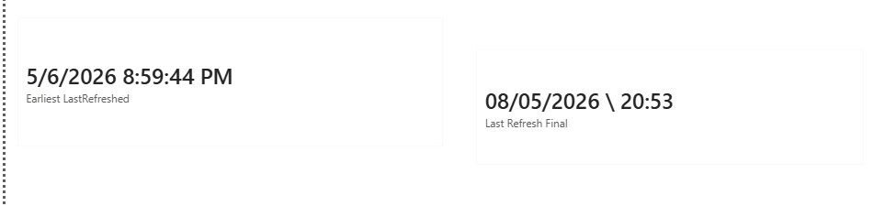
Look what is power BI server
- make a report (use the last one that sir gave as an assignment)
- publish it on server (resource for server will be confirmed when available)
- see how to refresh data, and how frequent we can do it?
- create a web page and paste link created from server where you uploaded the dashboard

We need to create single pages in total.
with following requirements:
Overview
Added Date Analysis
Date of Collection Analysis
Processed Analysis
Validated Analysis

Here are the requirements for the dashboard:
*Overview Page:*
We need to create these visuals:
1. *Funnel Chart*
* Sequence: Added Date → Date of Collection → Processed → Validated
2. *Bar Chart (Stacked or Clustered – your choice)*
- Based on *Specimen* field (around 10 types in dataset)
- It should show how many specimens are in each state: Added Date, Date of Collection, Processed, and Validated
3. *Another Bar Chart (same type as above)*
- From *Status* column, filter *SendToBilling*
- Show count of patients in each state: Added Date, Date of Collection, Processed, Validated
4. *TAT (Turnaround Time)* should also be included in Overview
*Other 4 Pages (Tabs):*
(Added Date Analysis, Date of Collection Analysis, Processed Analysis, Validated Analysis)
- All pages will have similar visuals, but analysis will be based on their respective field
- Each page must include:
- Age Group visual
- Gender visual
- TAT (difference between Added Date and Validated Date)
- Pie chart of Age Group (from previous assignment)
- With total count in center
- With custom tooltip
- You can also add more visuals to make the dashboard look better and more professional

*Important Instructions:*

- Do NOT create relationships between tables
- If Power BI creates them automatically, remove them
- Use *ALLSELECTED()* function since we are working without relationships * Import a *Scroller visual* from the internet and use it

Overall, the dashboard should look clean, professional, and visually appealing.

*Scenario: DNA Test Flow (Simple Explanation)*

Patient: Mr. Ahmed

Doctor ne kaha ke patient ka DNA test karna hai (Hearing aur Heart dono). Process kuch is tarah se hota hai:

- Date of Collection
Jis din sample liya gaya
Example: 8/2/2021
- Added Date
Jis time admin ne system mein record add kiya (patient details, doctor, test type, etc.)
Example: 8/2/2021 15:04
Note: Ye same din bhi ho sakta hai ya 1–2 din baad bhi

- Status: In Process → Processing
Jis time lab ne sample par kaam shuru kiya
Yani lab ne processing start ki
Example: 8/2/2021 00:00

- Status: Processing → Validate
Jis time lab ne processing complete karke result review ke liye bheja

- Status: Validate → Validated
Jis time final approval ho gaya
Ab result ready hai aur patient/doctor ko diya ja sakta hai

*Simple Flow:*
Date of Collection → Added Date → Processing Start → Review → Validated (Done)

Add the following visuals in your report
- *Funnel Chart:*
Sequence: Added Date → Date of Collection → Processed → Validated

- *Bar Chart*(clustered and stacked) one for specimen column and other for Requisition Type colmn⁠
- From *Status* column, filter *SendToBilling* . Show count of patients in each state: Added Date, Date of Collection, Processed, Validated ⁠ and show this in Visual Tree or if not available show in clustered bar chart.

- Import a *Scroller visual* from the internet and use it for the data discussed in point 3.

- Do NOT create relationships between tables
* If Power BI creates them automatically, remove them. Handle them through programming.
You can add more visuals accordingly to your own choice to make your dashboard clean and professional.

All these visuals should be in one report tab. Sir will set the width to 100 and then see your report. So set the width and height according to it.

No need to make 5 report pages, just make one page for all visuals

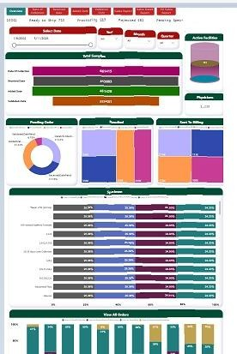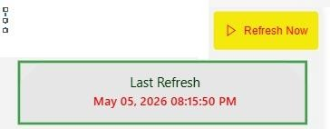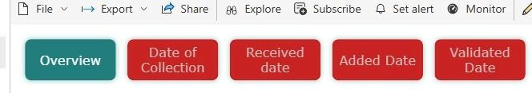
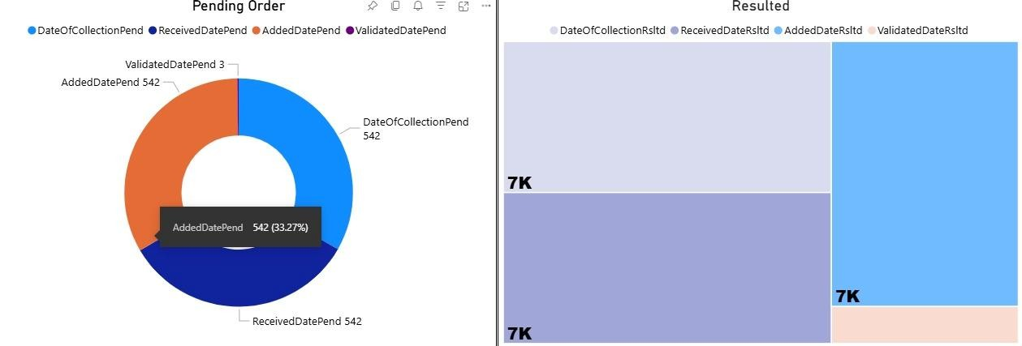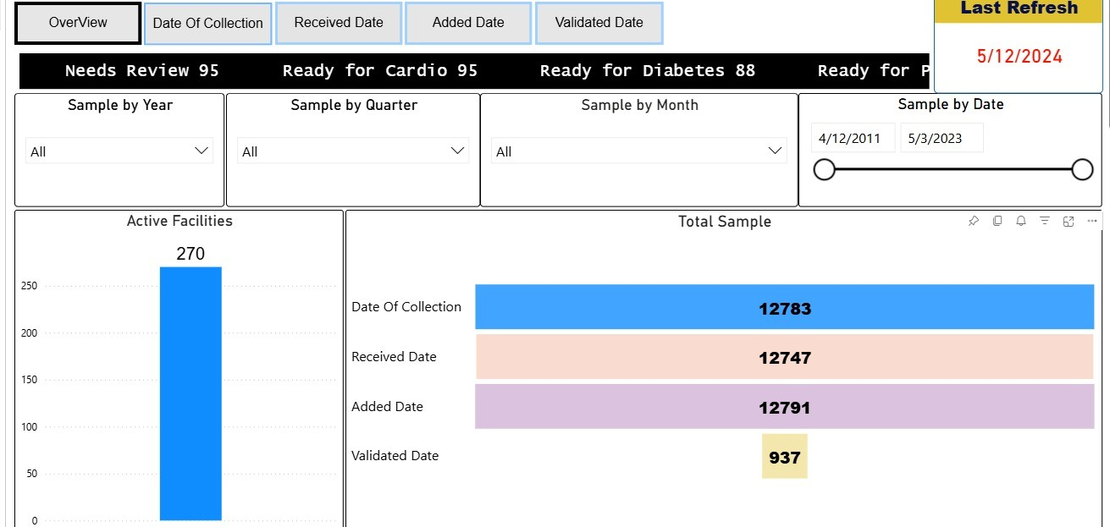

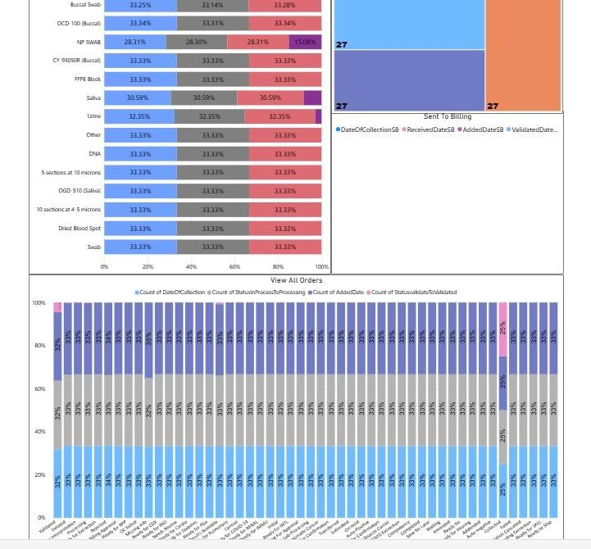

These are the 6 picture that the professor give to as for reference , If you think you can make much professional than this do it and also with the theame.
)
for my project i want exact like this report page which are down below
